Test Plan

SEDL 7556

Created By
Eck, Brian

Problem Description
Auction start events were showing up twice in the order’s history as shown below.
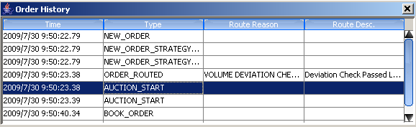

Resolution
Changes were made to AuctionServiceImpl.java in order to correct this problem. A merge issue introduced multiple “for” loops duplicating auction publishing.

Test Case
1. Create a Complex Order product:
Buy Leg1 (option ABB Dec 30 Call): 1
Sell Leg 2 (option ABB Dec 35 Put): 1

2. Open the option and stock leg and enter quotes on both of them
L1 - 1.0-1.20 100x100
L2 - 1.0-1.20 100x100

3. Setup your complex order’s trading properties to allow for COA and volume deviation checks to route to TE.

4. Enter a Same side Spread Order: 0.19 debit x 10
- Verify Spread Order is routed to TE for auction

5. Check Order History and verify only 1 auction start event is listed.

Results
